

Guardrail End Treatment Maintenance Application

Standard Operating Procedure (SOP)

TPP, MNT, DES

**Table of Contents**

Purpose 2

Site Navigation 2

Layer List 2

Basemap Gallery 4

Zoom and Full Extent 4

Editing Window 5

Location Window 5

Filter Window 6

Attribute Table 7

Editing Existing Points 9

Adding a Point 10

Deleting a Point 12

Using Street View 13

Download the Data 14

Contact Info 16

# Purpose

Ongoing maintenance of your end treatment inventory can be accomplished using the Guardrail End Treatment (GET) web application. Existing end treatment location and attribute information can be edited or deleted, and newly installed end treatments can be added using the web application.

# Site Navigation

1. Links
2. Layer List
3. Basemap Gallery
4. Zoom and Full Extent
5. Editing Window
6. Location Window
7. Filter Window
8. Attribute Table

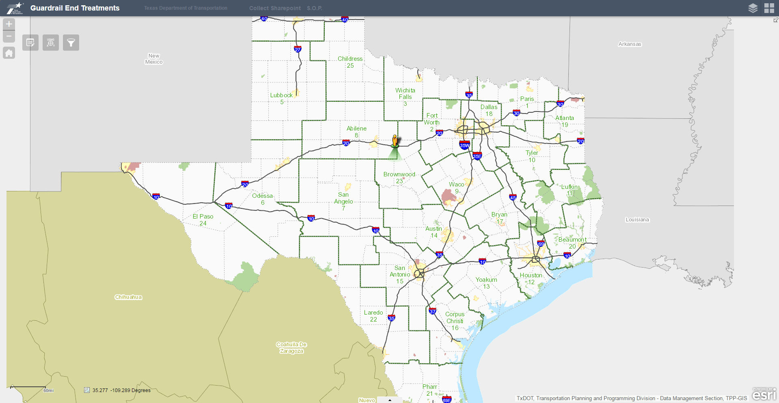

**8**

**7**

**6**

**5**

**4**

**1**

**3**

**2**

Layer List: Zoom in to see the guardrail end treatment points on the map.

Note: you must zoom in to approximately the county level before points will appear (due to the large number of points).

1. Open the Layer List window to view the layers shown in the map.
2. Click the “Legend Arrow” to display/hide the legend for each layer.
3. Check or un-check the ‘Display/Hide Checkbox’ to turn a layer on or off in the map.
4. Click the “Options Arrow” to view additional functionalities with the layer.

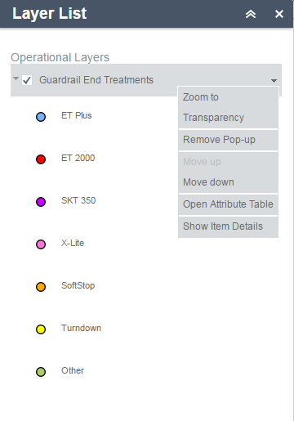

**Options Arrow**

**Display/Hide**

**Checkbox**

**Legend Arrow**

Basemap Gallery: Choose between different basemaps, including aerial imagery, topographic basemaps, and the TxDOT Statewide Planning Map basemap. Click on a basemap in the Gallery window to change background images. The various basemaps provide a variety of useful information when navigating the map.

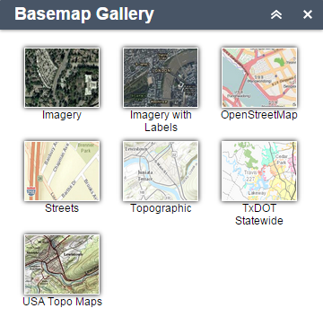

Zoom and Full Extent: Use these buttons to help navigate the map.



**Zoom In**

**Zoom Out**

**“Home”. Reset the map to the original map extent/view**

Editing Window: Open this window to edit GET points or access the Google Street View. Click a Guardrail End Treatment icon to add a new GET point to the map. The icon will remain shaded while active. Click the icon again to unselect it and cancel drawing.

This window must be open to re-locate any GET points or edit any GET point attributes.

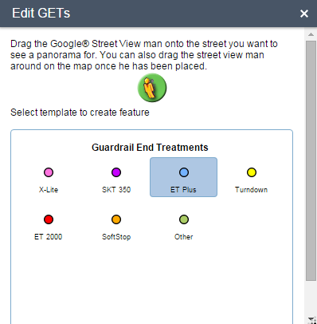

Location Window: This window is for navigating the map to a specific location based on known coordinates. Most commonly, this tool is used to find a GET location in the map using latitude and longitude coordinates collected in the field. Enter coordinates and click ‘Get Location’.

**Enter coordinates in alternative formats**

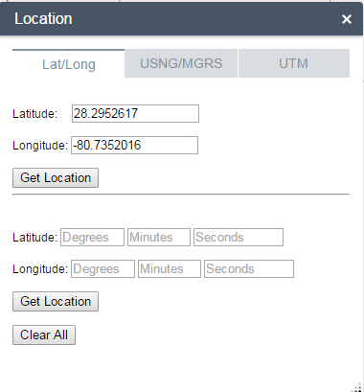

**Enter Latitude and Longitude coordinates**

**in Degree-Minutes-Seconds format**

**Enter Latitude and Longitude**

**Coordinates in Decimal**

**Degrees format**

**Clear the Located point from the map**

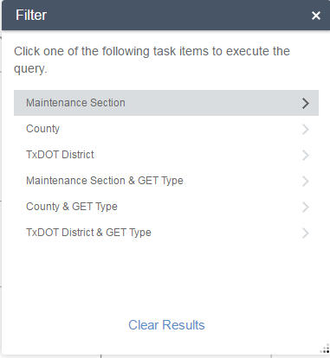Filter Window: The Filter window provides several options to filter the GET dataset. Choose to filter based on a boundary (Maintenance Section, County, or District) or boundary and treatment type.

Choose an attribute to filter by, choose the desired value from the dropdown, and click APPLY. The map will zoom to the points which meet the filter criteria and they will be overlaid with larger, transparent points. Click ‘Clear Results’ to remove the overlaid, filter layer from the map.

When choosing the filter values…

Check ‘User spatial filer to limit features’ to only filter the points in the current map view.

Check ‘Add result as operational layer’ to create a new layer from the filter result. The new layer will be listed in the ‘Layer List’ window. This allows you to turn on/off the filtered layer (‘Display/Hide Checkbox’) as well as the original GET dataset if you only want to view the filtered points.

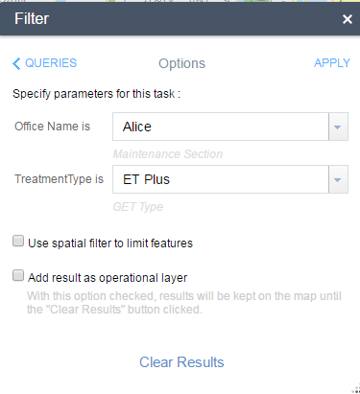

c

c

Attribute Table: Click the arrow button at the bottom center of the map to open up the Attribute Table window. By default, the attribute table for the entire GET dataset will is available. Click this arrow button again to hide the Attribute Table window.

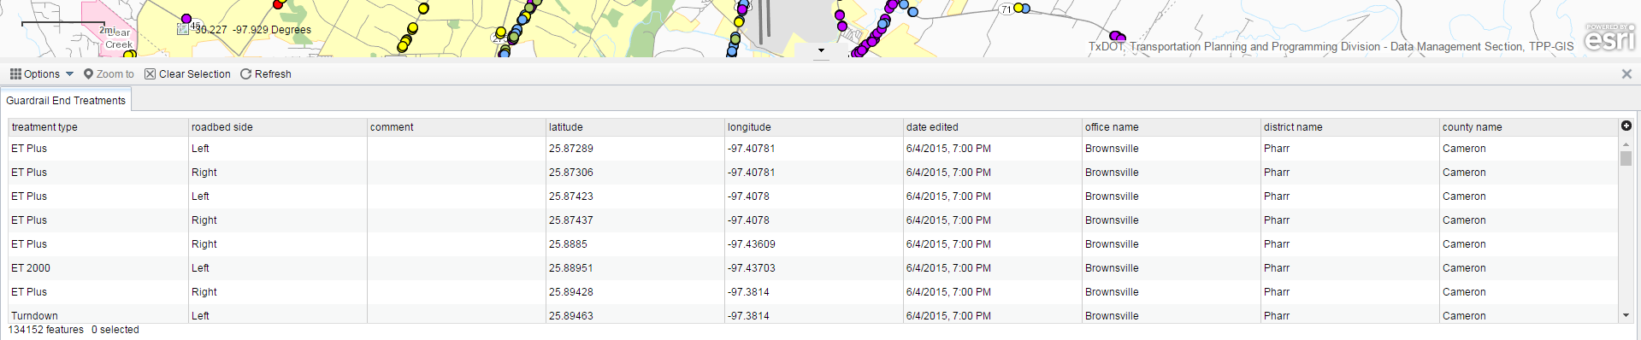

c

You can click a record in the Attribute Table to *select* it and then you can choose ‘Zoom to’ to navigate the map to the chosen record. Click ‘Clear Selection’ to clear the records you have selected.

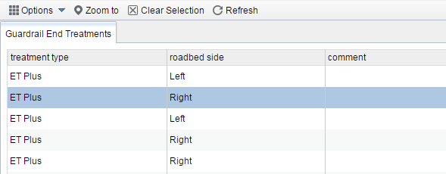

Click the ‘Options’ button to view additional functionalities with the layer including:

1. Show Selected Records – view only the selected records in the table
2. Filter by Map Extent – view only records in the table which are points in the current map view
3. Show/Hide Columns – turn on and off attribute fields
4. Export to CSV – download the current table into a CSV for using the data in Excel

If you Filtered the dataset and checked the ‘Add result as operational layer’ option, choose ‘Open Attribute Table’ from the options listed by the ‘Options Arrow’ in the ‘Layer List’ window to view the Attribute Table for a filtered layer.

This allows you to view the attributes for the filtered records as a table. Once viewing the table, you can choose the ‘Export to CSV’ option to download the filtered dataset as an Excel table.

### 

# Editing Existing Points

1. Click on the Edit GETs button to begin editing.  
    
2. With the Edit GETs dialog open, click on a point to edit its attribute information. A dialog box will open, as shown below. Click in any of the available text boxes to edit that attribute. The OBJECTID, Latitude, and Longitude fields are not editable.  
   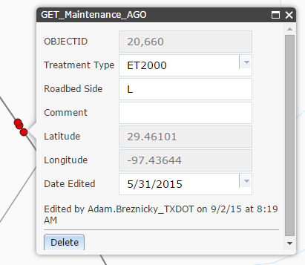
3. To relocate a point, simply select it and drag to a new location.

# Adding a Point

1. Click on the Edit GETs button to begin editing.  
    
2. With the Edit GETs dialog open, select the desired end treatment type. Your mouse will display a small tool tip with the message “Click to add a point (Press and hold CTRL if you would like to enable snapping).” Click in the desired location to place a point.

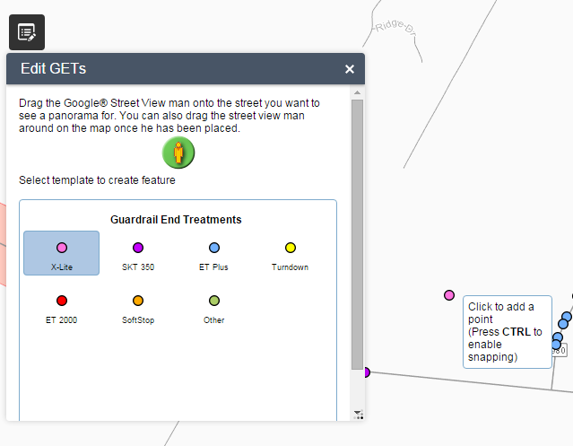

1. After adding the point, the attribute dialog box will open and you may enter your attributes. Click the X in the top right corner to save and close the dialog box.  
   
2. You may also click the Delete at the bottom, if you decide not to keep the point.

# Deleting a Point

1. Click on the Edit GETs button to begin editing.  
    
2. With the Edit GETs dialog open, click on a point to open the attribute dialog box.
3. Click the Delete button in the lower left corner.  
   

# Using Street View

1. Click on the Edit GETs button to begin editing.  
    
2. With the Edit GETs dialog open, select the Street View peg man and drag him to a road. A Google Street View window will open. The window will remain open until you close it. You can resize the window and position it on a second screen (if you have one).

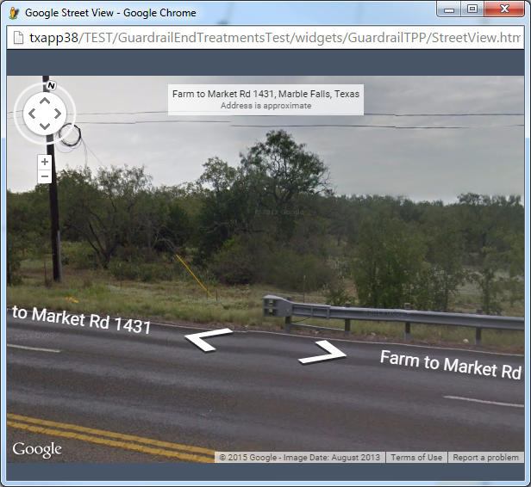

1. Pan around in the street view window to search for guardrail end treatment locations.

# Download the Data

There are two options to download the GET data.

1. Download the entire GET dataset as geospatial data (shapefile, file geodatabase, etc.)
   1. Open the ‘Layer List’ window.
   2. Click the ‘Options Arrow’ for the Guardrail End Treatments layer and choose the ‘Show Item Details’ option. You will be redirected to the ArcGIS Online service page.

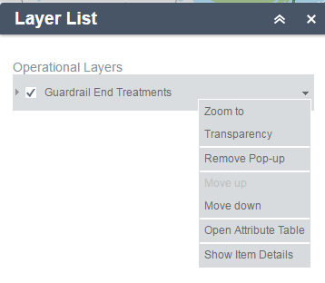

* 1. Click ‘Export’ and choose the format you wish to download the data in.

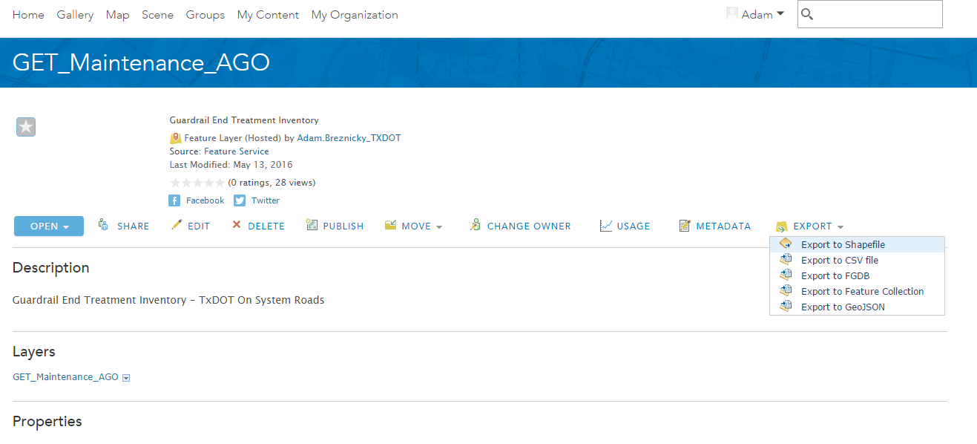

* 1. You will be asked for a Title, Tags, and Summary of the data.

Title the data uniquely for your reference. You also must enter a tag in the Tags section. Any random word will do; we suggest a random critter (ex. Muskrat).

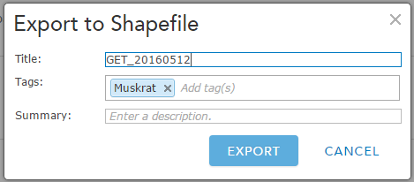

* 1. Click ‘Export’. ArcGIS Online will copy the data to your AGO account and will reside in your ‘My Content’ page (this may take a couple minutes). It will automatically redirect you to the copied data page in your ‘My Content’ page.
  2. Click ‘Open’ and then ‘Download’ to download the copied dataset. The copy will reside in your AGO ‘My Content’ until you delete it.

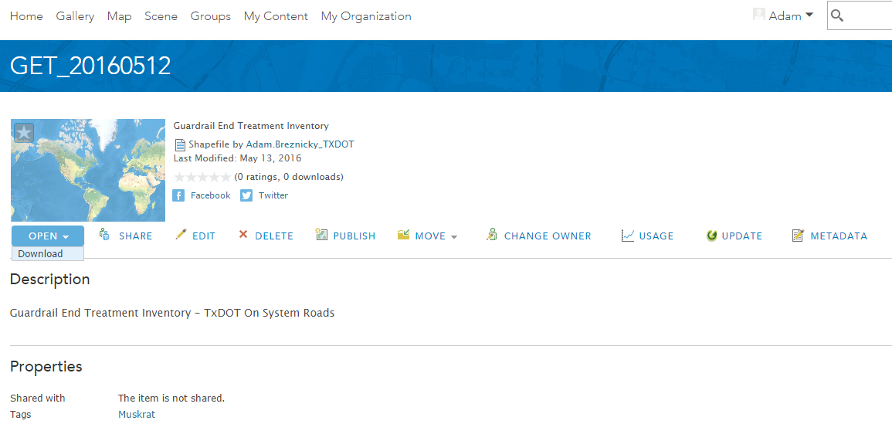

1. CSV table for use in Microsoft Excel.

You can use the method outlined in #1 and choose the CSV option. Alternatively, you can open the Attribute Table for the entire dataset or a filtered layer.

* 1. Open the Attribute Table for the layer you wish to download as an Excel CSV.
  2. Click the ‘Options’ button in the top left corner of the table. Choose the ‘Export to CSV’ option.

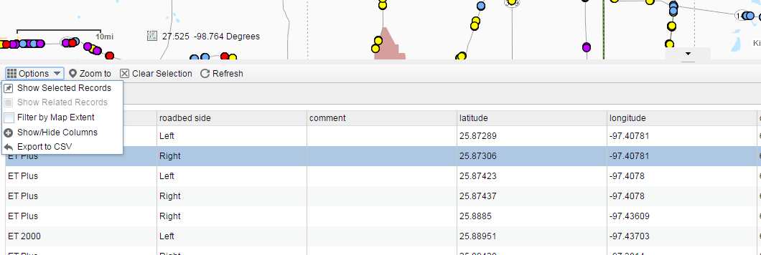

* 1. You will be prompted to confirm you would like to ‘Export data to CSV file’. Click ‘OK’. The CSV will download.

# Contact Info

For technical issues please contact TP&P.

[TPP-GIS@txdot.gov](mailto:TPP-GIS@txdot.gov)

(512) 486-5052